Installation Guide
jWebSocket
Representation of data in real time through graphics using jWebsocket framework.
1.0

Versioning Control
Date | Version | Description | Author
20/02/2012 | 1.0 | Preparing the document. | Merly López Barroso

- Process application download
To install this application it is necessary to download jWEbSocket client and server packages. The application is available for download at the following address:
http://jwebsocket.org/downloads .
Packages | Size
Charting Server | 162.5 Kb
Charting Client | 5.6 Mb

- Features of the installation environment
You need a server on which is mounted the database application.
- Installation process
The application can be installed in two different ways, according to the operating system you are working.
Linux: must have previously installed Apache and then to copy in / var / www / the client application. You must give permission to access it.
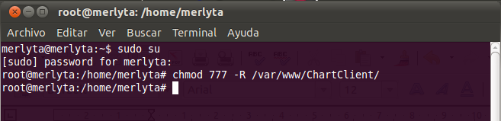

The application server may be located anywhere on the machine. Before running the client in the browser must be set to run the server on an IDE.

Windows: previously you must install the Wamp application that creates the folder C: \ \ wamp \ www, in this url must be copied the client application. The server application can be stored in any location. Before running the client browser must be set to run the server on an IDE.

4. Configuration Options
4.1 Sigar libraries Locations.

For the full operation of this application is necessary to copy some of the native libraries that have Sigar (System Information Gatherer And Reporter) library that allows us to get data from our computer.
Next the locations where should be copied the libraries will be described:

Archives | Linux | Solaris | Windows
32 bits | libsigar-x86-linux-1.6.4.so | libsigar-x86-solaris.so | sigar-x86-winnt.dll
64 bits | libsigar-amd64-linux.so | libsigar-amd64-solaris.so | sigar-amd64-winnt.dll
Directions | /usr/lib | /usr/lib | c:\program file\java\jdk\bin

This is because Sigar API is a multi-platform cross-language library and command-line can access the operating system tool.

5. Putting into operation
The application is operated when the server jWebSocket is started. If you make ​​any changes to the server and it’s running, it stops and starts again so the changes are saved properly. After that you open the client charting in browsers that support WebSocket.
5. Application Management
For administration of Charting Demo can be supported in the manual that corresponds to this application.
In the event of any problems during installation of the application, contact:
Alexander Schulze
Fon: +49 (0) 2407 902486
Fax: +49 (0) 2407 902487
Mail: a.schulze@jwebsocket.org

